Ethics and Human Resource Information Systems
Mahmudul Alam
Colorado State University – Global Campus
Course Code: 20FC-CSC502-1
Dr. Isaac K. Gang
Saturday, November 1, 2020
Ethics and Human Resource Information Systems
A company is the collection of different people with special expertise. Every department plays an important role for the company to function properly. Human resource is the set of people who is an important part of the organization. They oversee planning, coordinating events, recruiting, interviewing, and hiring new staffs. Human resource management system provides support to HR team with software to handle new employee data and keeping track of many business-critical data. In this age of technological revolution there are many systems that provides HRIS services. Ethical vulnerabilities can be raised with some of those systems. The way those system handles date can be questioned. There are many liabilities issues associated with HRIS, with this changing times it more critical then ever to take in consideration all the flaws of an HRIS systems. Planning properly to patch up the flaws can make the system better built to handle modern treats and changing work environments.
HR oversee collecting and maintain detailed record of an employee’s personal information. HRIS is a dataset with all the employee’s information, HR managers have a critical role to play protecting employee’s personal data. They should be aware of ethical and legal issues related to those critical data. “Human resource information system (HRIS) is defined as a software or online solution that is used for data entry, data tracking, and data management of all human resources operations of an organization.”( Ghosh) According to GHOSH a human information system is in place to better make sense all the data. Working with the data in a way that would lead to effective workflow and that will improve overall efficiency of the company. There are many components associated with HRIS, processes are as follows.
- Database management – Keeping track of all the employee data
- Time and labor management- Keeping track of employees’ time
- Payroll functions – uploading timesheet to the payroll software and making sure the pay.
- Benefit management – Informing all the employees about the benefits, analyzing feedback data.
- Employee interface- Being able to change direct deposit forms and updating general information.
- Talent acquisition – Finding the right talent and retaining employees to make the company grow.
The following model outlines how a basis HRIS functions. From input to output
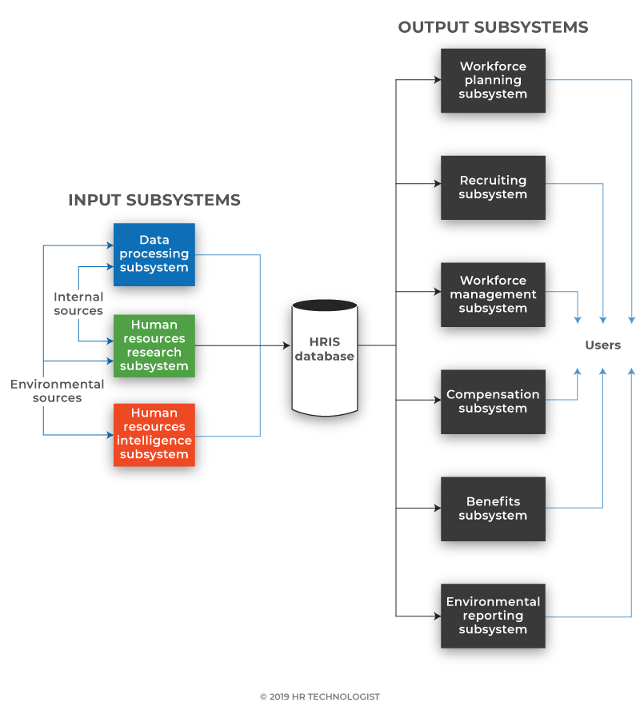
According to Ghosh

Three primary applications come with a human resource information system: talent development, talent management, and talent optimization, all with powerful data backup. There are many benefits associated with HRIS which could led to stronger organization. Some benefits are as follows.
- Reduced data storage expenses since a one-time investment is necessary
- Agility in data collection and review
- Reduced process duplication, which saves time, money and resources
- On-demand availability at the right time of the right data
- Stronger research and, therefore, wiser decisions
- Related career preparation which can be better communicated
- Improved report content and perspectives
Many organizations use HRIS solutions to make their HR processes simpler and efficient. Companies chooses a system based on their need. There are many companies proves these services.
EnterpriseAxis is a cloud-based HR information system for Software as a Service (SaaS) developed by The Gingrich Team, which also deals with other office applications such as employee augmentation and outsourcing services. Since it is a cloud based cyber security can a growing concern for the company. Data breach could easily compromise customers data and critical business data. According to their disclosure agreement, “there may be links to other websites on this section. Separate privacy and data collection policies may be open to retailers and other third parties connected to the Website. We take no responsibility for such individual policies and have no liability. References to any third party name, trade mark, product or service on this Site or links to third party websites are given solely for your convenience or as a source of income to us and do not constitute or imply in any way that we support, sponsor or suggest third parties and their details, products or services.” (Privacy Policy) Sensitive data can not be updated because Your data is transmitted over an authenticated and encrypted link when you provide some confidential information, using the Protected Socket Layer (SSL) to protect your privacy. According to companies policy there are no full warranty. But they will disclose any security breach of the system.
HRM Labs, established in 2015, tailors its solution to the country and industry you are based in. They may, for example, provide paylips with configurable payment items to indicate an exception (tax, allowance, deduction, reimbursement) such as employee data. After analyzing their privacy policy “We may disclose your personal data: where such disclosure is required for performing obligations in the course of or in connection with our provision of the goods or services requested by you; or to third party service providers, agents, and other organizations we have engaged to perform any of the functions listed in clause 5 above for us.” (Data Protection Notice) their disclosure policy seems unethical due to the fact they are willing to disclose information to third part under certain condition. Data should be private and should not be distributed or disclosed under any circumstances. The retention of personal data will be kept if it is necessary. There are no liabilities associated with the system, which might be a area to focus for this company. HR can identify why they are not feeling safe enough to give some sort of liabilities.
Common Office has been supplying customers around the world with groundbreaking Cloud-based HR applications for over a decade. They are hyper-focused on safety, being audited by IBM and providing validation of logins, multilevel encryption, internal audits, and backups of nightly data. Every HRIS system will deal with sensitive data, keeping data safe and secure should be their main concern. Data should be kept in a private server locked away from the internet, even thought that might cause delay while accessing the data. “To service providers or Partners that they have engaged to perform business-related functions on our behalf—this may include service providers that: (a) conduct research and analytics; (b) create content; (c) provide customer, technical or operational support; (d) conduct or support marketing (such as email or advertising platforms);”( A digital service presented to you by Common Office, LLC. (n.d.))
Federal government are usually slow to react to the changes happening to the systems. “There is no general federal or state law creating or protecting privacy in the workplace. The U.S. Constitution's First Amendment free-speech clause and the Fourth Amendment protection against "unreasonable searches and seizures" apply only to action by the government, not to private-sector employees.”( HUBBARD) data privacy and data security law is very fragile in the united states of America. HRIS systems deals with lots of private and sensitive persona data, data breach could do serious hard to the businesses and to the people. Government should take quick actions to add new laws and regulations related to data privacy. In long run it can only help and the country function better. “ In addition to legal problems, the issue of societal/ individual rights versus computer-based personnel information systems can have other dysfunctional consequences for organizations: employee mistrust of management, lowered commitment to the organization, and increased governmental regulation, among others.”( TAYLOR) there is a growing concern about trusting employers with employees data, only right government rules and regulation can solve all the problem and help everyone to innovate freely and build a better future.
Conclusion
All administrators of human resources must continuously be Knowing the ever-changing legislation and regulations. HR should be aware of all the possible cyber threats and systems that can be used to improve companies productivity. There are many benefits of using an HRIS system but due to the lack of proper laws and regulation ethical issues might be faced while using one of those systems to better manage a company and its people. Most importantly companies critical information and personal data. We are racing towards the future and ethical laws must be implemented by the government to better produce technology.

References
TAYLOR, G. S.; DAVIS, J. S. Individual privacy and computer-based human resource information systems. Journal of Business Ethics, [s. l.], v. 8, p. 569–576, 1989. DOI 10.1007/BF00382934. Disponível em: http://search.ebscohost.com/login.aspx?direct=true&db=ssf&AN=508328616&site=eds-live. Acesso em: 1 nov. 2020.
HUBBARD, J. C.; FORCHT, K. A.; THOMAS, D. S. Human Resource Information Systems: An Overview of Current Ethical and Legal Issues. Journal of Business Ethics, [s. l.], v. 17, n. 12, p. 1319–1323, 1998. DOI 10.1023/A:1005735506589. Disponível em: http://search.ebscohost.com/login.aspx?direct=true&db=bth&AN=12132260&site=eds-live. Acesso em: 2 nov. 2020.
Ghosh, P. (n.d.). What Is HRIS? System, Model, and Application. Retrieved November 02, 2020, from https://www.hrtechnologist.com/articles/performance-management-hcm/what-is-hris/
Read, T., Alyson Taylor·June 20, 2., &amp; Views, 5. (2020, October 28). 10 Best Online HRIS Systems Of 2020. Retrieved November 02, 2020, from https://peoplemanagingpeople.com/tools/hris-human-resources-information-system/
Data Protection Notice. (n.d.). Retrieved November 02, 2020, from https://hrmlabs.com/pdpa-gdpr-policy/
Privacy Policy. (n.d.). Retrieved November 02, 2020, from http://enterpriseaxis.com/privacy-policy/
A digital service presented to you by Common Office, LLC. (n.d.). Retrieved November 02,
2020, from https://commonoffice.co/privacy.html

